Welcome to
1st Medical Battalion
Camp Pendleton, CA

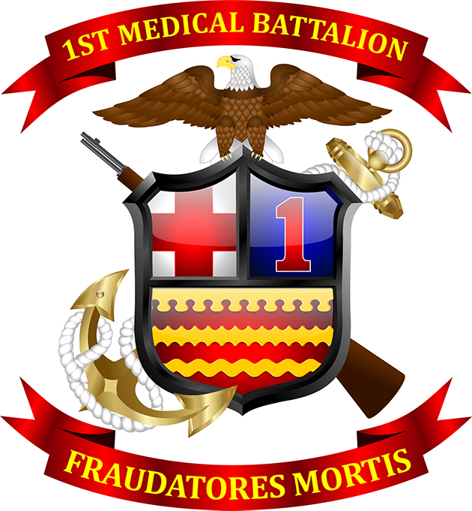

“CHEATERS OF DEATH”

1st Medical Battalion Check-in Guide
1
Command Sponsorship Coordinator
a. In-processing.
1. Read Welcome Aboard package for all available resources the unit offers.

2. Contact your assigned Sponsor prior to reporting to the unit.

b. Command Sponsorship Coordinator.
1. Ensure Welcome Aboard package is sent prior to member’s arrival to the unit.

2. Assign a qualified Sponsor prior to member’s arrival.

3. Schedule members for the next available Command Indoctrination Course.
2
Medical (MCMH) (Bldg. 22190, Medical Records)

a. In-processing.

1. Check-in with Medical (MCMH) within five business days from reporting date.

2. Provide hard copy of your Medical Health Treatment Record to MCMH.

3. Update medical record’s Privacy policy and pencil entries.

4. Newly check-in members will contact Tricare West Region at 1-844-866-9378
or visit Tricare website at www.Tricare.mil/moving and follow the instructions for
transfer enrollment of Tricare prime option to the appropriate MCMH within 30 days of
their report date.

b. Marine Centered Medical Home (MCMH) Staff.

1. Collect and file member’s medical record.

2. Verify medical readiness status in MRRS.

3. Screen the member’s medical record within 30 days of receipt of the record,
add the member to the “new check in screening” document and provide the document to
the appropriate provider.

4. Enroll members to Medical Surveillance Program, if applicable.

2
Dental Clinic (Bldg. 22190, Dental Records)

a. In-processing.

1. Provide hard copy of your Dental Health Treatment Record to the Dental clinic.

2. Update dental record’s Privacy policy and pencil entries.

b. Dental Staff.

1. Collect and file member’s dental record.

2. Verify member’s dental class status, and schedule an appointment, if necessary.
The scheduled appointment will occur if the member is due within 30 days.
33

S-1/CPPA (Bldg. 22183, 1st Deck)

a. In-processing.
1. Required items to bring prior to reporting to S-1/CPPA:
- Original/Stamped PCS orders
- Service Member’s Group Life Insurance (SGLI),
- Updated Record of Emergency Data/Dependency Application (RED/DA)
- New address to receive mail
- Flight itinerary (if applicable)
- Travel claims (transportation & lodging receipts), if applicable

2. (Marine’s only) Upon completion of the administrative check-in with H&S. Marines will need to complete administrative check-in in IPAC.

b. S-1/CPPA Staff.

1. Personnel Specialists shall stamp the reporting member’s PCS orders.

2. Provide the appropriate forms to the member to submit the member’s gain and travel (when applicable) to Personnel Support Detachment (PSD) via Transaction Online Processing System (TOPS).

3. Ensure all PCS reimbursement claims are submitted in a timely manner.

4. Verify Record of Emergency Data/Dependency Application (RED/DA) in NSIPS.

4
S-1/Administration & Mail Clerk (Bldg. 22183, 1st Deck)

a. In-processing.
1. Newly check-in members must accurately fill out the forms provided by S-1.

2. All personnel will update and verify NFAAS via link: https://pki.navyfamily.navy.mil/main/my_home/
3. Family Care Plan requirements to have a secondary caregiver contact information.
b. S-1/Administration & Mail Clerk.
1. Gain newly check-in members into Marine Online (MOL)

2. Ensure to check box option for Marine Corps Total Force System (MCTFS)

3. Enter member’s data into Billet Identification Code (BIC) database

4. Add member’s mailing address into the Directory File Card (DFC) cards

5. Ensure NFAAS is verified by member and Family Care Plan updated.
5

S-1/Educational Services Officer (Navy Enlisted only)
a. In-processing.

1. Required items to bring prior to reporting to ESO:

- Copies of the last three Evaluations
- Letter of Extension (if applicable)

b. S-1/Educational Services Officer.

1. Verify the Enlisted Advancement Worksheet (EAW), time in rate and EAW
completion, if applicable.
6
Substance Abuse Control Officer
a. In-processing.
1. All reporting members must provide a urine sample within 72 hours of
reporting. Personnel that check in on Fridays must provide a sample the same day.

b. Substance Abuse Control Officer.
1. Educate members of SACO policies and conduct safety brief

2. Issue a serialized Arrive Alive card (if over the age of 21)

3. Collect and process the urine sample accordingly.
7
Force Preservation Council (FPC)

a. In-processing.
1. Must be completed within 5 business days from the reporting date.
b. Company Commanders/Senior Enlisted Leader.
1. Conduct interview with the new reporting members.
2. Create FPC slide for the new reporting members.
8
Command Fitness Leader/Assistant CFL
a. In-processing.
1. All reporting members must complete their BCA wearing their Physical
Training Uniform within five days of reporting.

2. Marines will meet with Platoon Sergeant and conduct weigh-in within the first day of reporting.

b. Command Fitness Leader/Assistant CFL.
1. PFA Record Verification for Newly Reporting Members.

2. Must administer a BCA spot-check within 5 working days on all newly
reported Sailors to ensure members are within Age-Adjusted Standard (AAS).

3. Enter member’s data into the CFL battalion tracker.

4. Ensure all members participate in an official PFA (BCA and PRT), regardless
of their time onboard (if medically cleared).
9
S-2 / Security Intelligence (must be completed prior to S-6)
a. In-processing.
1. Training requirements to bring to S-2.
- SERE 100.2 Certificate link
https://www.marinenet.usmc.mil or https://jko.jten.mil/
- DoD Annual Security Awareness Refresher link https://securityawareness.usalearning.gov/
- Counterintelligence Awareness and Reporting for DoD Certificate link https://securityawareness.usalearning.gov/
2. Complete ISOPREP form issued by Security Chief.

b. S-2/Security Intelligence Staff.

1. Confirm security clearance if applicable.

2. Maintain the member’s profile for the Command Security Program.

3. Conduct ISOPREP and sign the Non-secure Internet Protocol Route (NIPR) and Secure Internet Protocol Router (SIPR) System Authorization Access Request (SAAR) forms from S-6 when applicable.
10
S-6 / Communications (Bldg. 22181, 2nd Deck)

a. In-processing.

1. Bring copy of Navy Cyber Awareness Challenge (YYYY)–(DOD-IAA-V18.0) FY link https://www.marinenet.usmc.mil or https://jko.jten.mil/
b. S-6/Communications Staff.
1. Generate a NIPR and SIPR (if applicable) SAAR for the member. Once the
member’s account has been created, S-6 personnel will notify the member and provide the appropriate computer access based on the member’s company and position.

2. Add all new reporting members to the battalion email distribution list
1MLG_Med_Bn_All_Hands@usmc.mil and to appropriate group email distribution list.
STOP
The steps above must be completed first and in order.

Special Assistance Platoon (SAP)/Adjutant’s Office

a. In-processing.
1. For Officers, bring last 3 FitReps, Bio, OSR, PSR, and Résumé/CV.
b. Adjutant’s Office.
1. Send Calendar Invite to reporting members based on TRIAD’s availability.
- Commanding Officer (E7-E9, O4 and above)
- Executive Officer (E7 and above)
- Command Master Chief (Enlisted)
S-1/DTS/GTCC (Located in Bldg 2281, 2nd deck)
a. In-processing.
1. Bring required items to DTS/GTCC section.
- Government Travel Charge Card (GTCC)
- Travel Card Program/ Travel Card 101 Certificate link http://www.defensetravel.dod.mil/site/training.cfm
- TDY Travel Policies 101 Certificate link http://www.defensetravel.dod.mil/site/training.cfm

2. If reporting personnel does not have GTCC, the individual will need to complete Citibank application at https://home.cards.citidirect.com/CommercialCard/login and return to S-1 once GTCC is received.

3. Reporting personnel will update information in Defense Travel System.

4. Complete Statement of Understanding (SOU).

b. S-1/DTS/GTCC Staff

1. Gain reporting members into Defense Travel System (DTS) and CitiBank.

2. Validate member’s updated information in DTS.

3. Ensure members has unexpired GTCC.

4. Collect and File all required training certificate and SOU.

S-1/Administration/Pers-Tempo (Located in bldg. 2281, 2nd deck)

a. In-processing.

1. New reporting member will provide social security number.

b. S-1/Administration/Pers-Tempo Staff.

1. Gain the reporting member into the system and update the system accordingly if the member deploys or departs from the command.

S-4/Logistics (Sailors and Marines living in the BEQ only)

a. In-processing.

1. New reporting member will bring original PCS order.

b. S-4/Logistics Staff.

1. Ensure available room is ready for occupancy and keys is issued to the member.

Command Career Counselor / Career Planner (SAP)

a. In-processing.

1. The reporting member is responsible for providing their PCS orders (Navy) and member’s data summary.

b. Command Career Counselor/Career Planner (SAP).

1. Validate the member data summary and orders to ensure member has enough years in service. If further action is needed in regards to the member’s Transition Readiness Seminar (TRS) services, the career planning will take for action.

2. The Career Planner will check the Marine’s personnel records on MOL for any re-enlistment services, special duty assignments, or TRS services.

FitRep/Evaluation Coordinator

a. In-processing.

1. Bring copy of the most recent FitRep (Officers) and Evaluation (Enlisted).

b. FitRep/Evaluation Coordinator.

1. FitRep/Evaluation Coordinator will verify advancement eligibility.

Deployment Readiness Coordinator

a. In-processing.

1. Complete Family Readiness Contact Form (NAVMC 116544).

2. Know the available resources to assist on your transition (see Welcome Aboard Package).

b. Deployment Readiness Coordinator.

1. Collect and file Contact Form (NAVMC 116544).

2. Educate members on all available resources the unit offers.
Legal Office (E-6 and above only)
a. In-processing.

1. Complete Court Martial Questionnaire provided by the legal office.
b. Legal Office Staff.

1. Educate members on the battalion legal process and file Court Martial Questionnaire.

Unit Awards Coordinator (E-6 and above only)

a. In-processing.

1. Upon receiving green-side email access, the reporting member shall contact the Unit Award Coordinator to request Awards Processing System (iAPS) access.
b. Unit Awards Coordinator.
1. The Coordinator will provide the steps to request and will grant Awards Processing System (iAPS) access upon completion.
2. Educate members on the local award process and policies.

S-3/Training (Check in here AFTER receiving your gas mask from IIF)

a. In-processing.

1. After receiving the issued gas mask from IIF, the reporting member will bring all required computer based training certificates (see Welcome Aboard Package) to include any instructor certificates.

2. Create Marine Corps Training Information Management System (MCTIMS) account.

3. Ensure to sign green log book.

4. Member must ensure to attend the next available Command Indoctrination for the Face to Face trainings.

b. S-3/Training Staff.

1. Verify member’s MCTIMS account has been created, verify completed training, and identify any training requirements in accordance with the command’s mission.

Watch Bill Coordinator

a. In-processing.

1. The reporting member will report to their respective watchbill coordinator and provide the training outlined by S3-T (see Welcome Aboard Package). All E-6 and above are required to qualify on the pistol range in order to stand Officer of the Day duty.

b. Watch Bill Coordinator.

1. Validate complete training and ensure members are inform of the local security watch policies and SOP.

2. Members will be added on the watch bill upon completion of the required training.

FMF/FMFWO Coordinators

a. In-processing.

1. Bring copy of the PCS orders.

2. Enlisted Sailors will report to their respective FMF coordinators.

3. Navy Officers will report to the FMFWO coordinator.

b. FMF Coordinator.

1. The FMFWO and FMF coordinators will provide the reporting member with the pertinent information and materials required to qualify for their respective pins.

2. FMF books will be issued as well as the trackers updated accordingly.

Company Commander & GySgt/1stSgt/SEL

a. In-processing.

1. Report to your designated Company Commander and GySgt/1stSgt/SEL.

b. Company Commander.

1. Conduct interview and ensure members check-in process are in accordance with the battalion order.

Proficiency and Conduct Pros/Cons (Marines only)

a. In-processing.

1. Pros and Cons from all previous commands are required. Marines will bring Alphas/Orders/SRB documents

b. GySgt/1stSgt.

1. Conduct interview and record review of the new reporting Marines.

Military Family Life Counselor (MFLC)

a. In-processing.

1. The reporting member is responsible for calling the MFLC at 760-573-0346 to receive a brief concerning short-term, non-medical counseling to service members and their families.

b. Military Family Life Counselor (MFLC)

1. Inform members concerning short-term, non-medical counselling to service member and family.

Armory

a. In-processing.

1. The reporting member is responsible for checking into the armory to receive their weapons card. The member must obtain the signature for their weapons card from their respective Company Commander or Senior Enlisted Leader.

b. Armory Staff.

1. Validate weapons card and assigned a weapon for the new member.

Motorcycle Safety (Motorcycle riders only)

a. In-processing.

1. Bring license, registration, training documents.

b. Motorcycle Safety Coordinator.

1. Educate riders on the policies, motorcycle safety and validate all requirements.

Individual Issue Facility (Located in bldg. 2230, see map for location)

a. In-processing.

1. The reporting member must report to Individual Issued Facility (IIF) to receive their issued gear. The member can walk in between 0700-1700 or schedule an appointment at https://member.dpas.dod.mil/.

2. Bring copy of PCS order and Check-in sheet.

3. Ensure to receive a copy of the IIF receipts from their staff and matches with all issued gears.

Safety Section

a. In-processing.

1. The reporting member will report to Safety and sign the log book.

2. Create/Validate Enterprise Safety and Management System (ESAMS) account.

b. Safety Representative.

1. Safety will add all personnel to the Enterprise Safety and Management System (ESAMS).

Supply (Located in bldg.. 2242, see map for location)

a. In-processing.

1. After completing the IIF process, the member will report to Supply with a copy of their history of assignments (enlisted Sailors only) and orders. Enlisted Sailors with a break in Marine Corps service, or at initial assignment to a Marine Corps unit, is eligible to receive the Special Initial Utility Uniform Allowance per reference MCBUL 10120 CH-4.

b. Supply Staff.

1. If the member is eligible for a uniform allowance, Supply representatives will provide the documentation and oversee the process to ensure the member receives their uniform items.

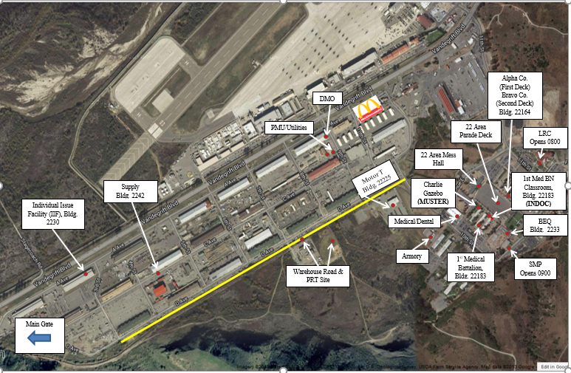

Unit Voting Assistant Officer (UVAO)

a. In-processing.

1. Ensure to check in with the Unit Voting Assistant Officer.

b. Unit Voting Assistant Officer.

1. Educate newly reporting members on the resources available and ensure that military voters understand their voting rights, how to register to vote absentee, and have access to accurate nonpartisan voting information and assistance.

Command SAPR

a. In-processing.

1. Ensure to check in with the SAPR/VA.

b. Command SAPR representative.

1. Educate reporting members on the military SAPR program, resources available and provide contact information for immediate assistance.

Credentialing

a. In-processing.

1. All providers and nurses are required to stop at credentialing located at NMRTC Camp Pendleton, 4th floor/Room 4172. They can be reached at: (760) 719-5100, (760) 719-4418, or (760) 725-1577. Providers will receive hospital access and set up navy account with hospital IMD

b. LNO Staff.

1. Provide direct assistance on the credentialing process for all providers and nurses.

Main Side Library

a. In-processing.

1. New reporting members check-in to the base library to receive a library card and a list of services and resources provided. See Map below. Google Maps pin: https://goo.gl/maps/zsMKkWny2WY48nnNA

Family Housing Office (20 Area, Bldg. 200011)
a. In-processing.
1. Reporting members with the intention of utilizing base housing must contact the family housing office. The information is provided in the welcome aboard package via the assigned Sponsor.

Vehicle Registration
a. In-processing.
1. The member must bring their license, registration, insurance, and a smog test if applicable. Vehicle Registration is completed in the Pass and ID Center. Telephone #: 760-725-2442
Google Maps pin: https://goo.gl/maps/L9o8X2SVXpUjZZD88
END
S-1/Administration
a. New reporting member must complete the check in sheet and promptly returned to the S-1 Section. Ensure each section block in the check-in sheet are completed (stamp or sign/initials).
- S-1 staff will Issue BSO, PTAD, TAD Order.

